Laser Kinematics Derivation

Owen Lu

Electroimpact Inc.

owenl@electroimpact.com

*Abstract*—This document describes the method and assumptions used obtain the kinematic equations for the laser projector system. Notably, coordinates are taken within the projector frame.

# Introduction

This project has been undertaken in order to confirm an understanding of the laser project system and eventually develop better solving algorithms for the laser scanners. It has been historically noted that registration order of calibration points can create performance variations. This is not ideal as the input data set should result in one solution describing the location and orientation of the system.

# Coordinate frame defintion

The construction of the laser projector allows good choices for the axes to be made in order to simplify calculations. The two mirror axes are assumed orthogonal to one another from one another.

We select the first stage mirror to have rotational axis along the Z-axis while the second stage mirror has axis along the X-axis. Thus, the first stage mirror rotates about the origin.

# Plane geometry

The construction of the system is such that an easy choice of a coordinate frame can be made.

Two rotational axes ${\overline{v}}_{1},{\overline{v}}_{2}$ of the mirrors are orthogonal, to one another. The laser is also parallel to ${\overline{v}}_{2}$.

Thus, we can select laser vector $\overline{u}$ to be along the x-axis

|  |  |  |
| --- | --- | --- |
|  |  | () |

As a simplification the first plane is assumed to have no thickness, normal ${\overline{n}}_{1}$ and rotates about the line $L_{1}$ which is parallel to the z-axis.

|  |  |  |
| --- | --- | --- |
|  |  | () |

In Figure 1 this virtual plane represents a mirror plane of zero thickness and will be corrected for later in the model. The normal to the plane can be written in terms of .

|  |  |  |
| --- | --- | --- |
|  |  | () |

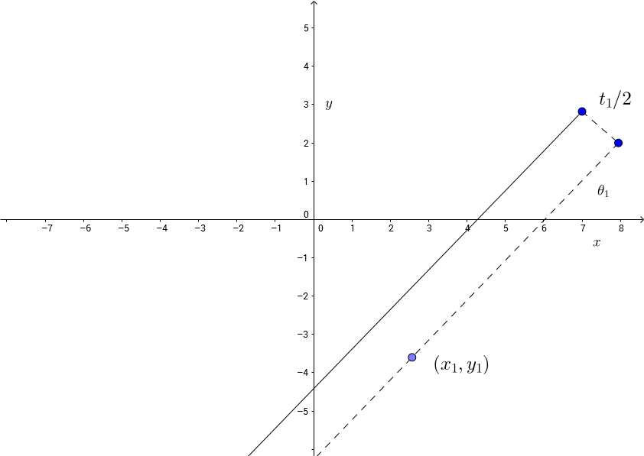

Figure – Defined plane geometry in $xy$ plane view

Therefore the mirror plane can be defined by a dot product expression.

|  |  |  |
| --- | --- | --- |
|  |  | () |

Now that the expression for the zero thickness plane is developed, an offset plane can also easily formulated. This offset plane will be shifted by half the mirror thickness $t_{1}$.

This can be done easily by substituting ${\overline{x}}_{1}$ for ${\overline{x}}_{1}+\frac{t_{1}}{2}{\overline{n}}_{1}$. Distributive law can then be applied to the dot product.

|  |  |  |
| --- | --- | --- |
|  |  | () |

Similarly, the same method can be applied to describe the second mirror plane, with normal ${\overline{n}}_{1}$ rotating about $L_{2}$ parallel to the x-axis. The diagram would be exactly the same as Figure 1 but with $z$ replacing the ordinate and $y$ replacing the abscissa.

|  |  |  |
| --- | --- | --- |
|  |  | () |
|  |  | () |
|  |  | () |

# Ray Reflection transformation

In order to find the ray emanating from the second mirror surface, the laser vector $\overline{u}$ must undergo two reflection transformations.

To find reflected vector $\overline{r}$ to input vector $\overline{d}$ reflected across plane of unit normal $\hat{\overline{n}}$, we can use the below equation.

|  |  |  |
| --- | --- | --- |
|  |  | () |

Let denote the ray vector after the first planar reflection

|  |  |  |
| --- | --- | --- |
|  |  | () |

Let denote the ray vector after the second planar reflection

|  |  |  |
| --- | --- | --- |
|  |  | () |

At this point since $\overline{u}''$ can be calculated, we only need point $\overline{p}$ the point where the laser intersects the second plane.

# Finding Laser-Mirror intersection

Since the laser originates on the x-axis we can generate a line .

|  |  |  |
| --- | --- | --- |
|  |  | () |

Substitution of $\overline{x}=s_{1}\overline{u}$ allows us to solve

|  |  |  |
| --- | --- | --- |
|  |  | () |

Therefore, the point $\overline{p}'$ which is the intersection of the laser and the first mirror plane is given below.

|  |  |  |
| --- | --- | --- |
|  |  | () |

Then the line used to find the intersection of the laser line and the second mirror is using line $R_{2}$ and the second mirror plane.

|  |  |  |
| --- | --- | --- |
|  |  | () |

Substitute and solve for

|  |  |  |
| --- | --- | --- |
|  |  | () |
|  |  | () |
|  |  | () |

The last point on the $z=k$ plane can be solved by using line .

|  |  |  |
| --- | --- | --- |
|  |  | () |

Solving for $s_{3}$ such that $z=k$ allows for the final point to be found.

Since $\overline{p}''$ has no $z$ components, we simply use the equation

|  |  |  |
| --- | --- | --- |
|  |  | () |
|  |  | () |

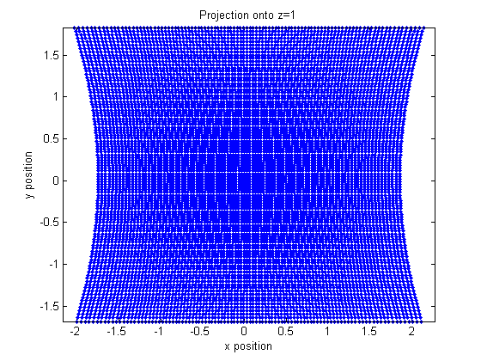

Figure – Projection points using $30<θ_{1},θ_{2}<60$

Therefore, the final equation describing a projection on plane $z=k$ can be written below:

|  |  |  |
| --- | --- | --- |
|  |  | () |

# Verification

Using Solidworks 3D sketches and work planes, the modelled system can be constructed to verify the calculations. Calculations using parameters matched by the Solidworks model have been verified to be exact matches.

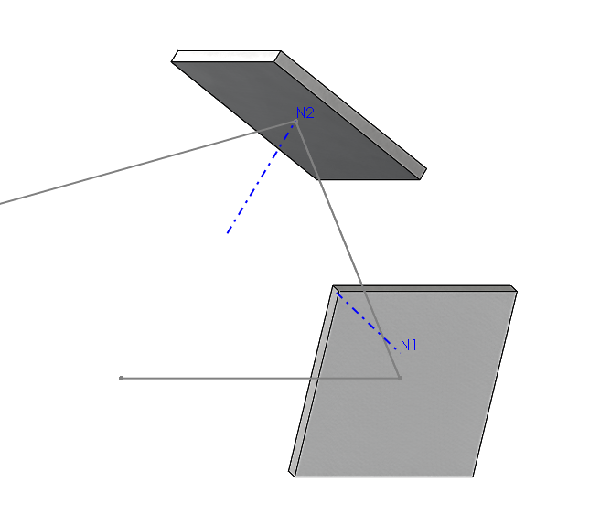

Figure – Ray reflection solid model for verification